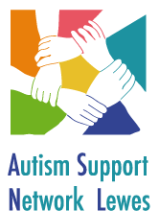

Consent Form – Photographs and Videos

I hereby authorise for my son/daughter……………………………………………..
to be photographed and/or video footage to be taken during any activity which is held by Autism Support Network Lewes (ASNL).

The pictures or videos may be viewed on the ASNL website or our ASNL facebook (members only) forum but ASNL will NOT pass on any photographs or video footage to other individuals or organisations, without prior parental consent given.

You will be asked annually to update this information and give your consent for the following year.

Parent/Carer Name:

Parent/Carer Signature:

Date:

Please would you kindly bring this along to the next meeting or send to the
address below. Thank you!

